A Project Report
on
VASAVI COLLEGE STUDENT INFORMATION SYSTEM

By
AKHILA CHINTA - 1602-13-733-002
HEPSIBA KOMATI – 1602-13-733-013
GANNU VINEEL – 1602-13-733-058


Department of Computer Science & Engineering
Vasavi College of Engineering
(Autonomous)
Ibrahimbagh, Hyderabad-31
2017

ABSTRACT

Vasavi college Student Information System brings the complete data regarding the students. Data includes Personal Information, Educational Information, Academic Details, Project Details, Transportation Fee, Medical Fee. It includes storing the information of the student and then retrieving it back. It is implemented using Pega Tool of Version 7.1.6 with the portal named Designer Studio. Pega platform brings an optimistic way to store, maintain and retrieve the data. The Application contains a CaseType named StudentInformationSystem which is divided into different milestones known as Stages and Stages are further divided into Steps. Each Step has a flow. In this Application, the access is given to a single Operator. Hence, we use Screen flow.

Acknowledgments (if any)

This is an acknowledgement of the intensive drive and the technical competence of many individuals who have contributed to the success of our project.

I am obliged and grateful to Dr. T. Adilakshmi, Professor and Head of the Department of CSE, Vasavi College of Engineering, Hyderabad, for her valuable suggestions and guidance in all respects during the course of B.E.

I am highly indebted to Mr. S. Vinay Kumar, Asst. Professor, CSE department, Vasavi College of Engineering, Hyderabad, for his valuable guidance and constant encouragement. He projected us with much needed direction and motivation to take up a project of this kind.

I would like to offer our special thanks to PEGA TEAM for taking a step to involve us in doing our major project on PEGA TOOL which will be useful in our future. I express my sincere thanks to all the faculty members and lab technical assistants of CSE department for their help and kind cooperation.

Finally, I would like to take the opportunity to thank my family and friends for their support through the work.

Table of Contents

1. Business Problem
2. Management Goals and Requirements
3. Current Process/Policy
4. Actors
5. How the Application is solving Business Problem
6. Implementation Details of the Solution
7. Future Enhancements
8. Conclusions
9. References

BUSINESS PROBLEM

The Vasavi College Student Information System is thrilled with the recent successful addition of the Student Information Case in College. Pega system architects have been asked to rapidly prototype & demonstrate a similar Case Type to improve the processing of Storing and Retrieving. The manual process is not only time consuming, but also prone to errors which lead to delays in requests being processed, rework and in some extreme cases, employees have either lost valid time off or the company has been out of pocket due to staff being given too much paid leave. Vasavi College has therefore decided to automate and improve this process in Pega 7.

Management Goals and Requirements

1. Ensure that Student records are stored correctly.
2. Automate as many of the steps as possible, speeding up the process
3. Ensure that Student records are retrieved correctly.
4. Ensure that the requirements & specifications are captured in the system to generate complete documentation
5. Meet or exceed the requirements as detailed below.
6. Automatically calculate any appropriate, useful values to help Administrators complete their tasks.
7. Ensure cases are processed expeditiously. All users should be encouraged to process tasks assigned to them within 4 hours and have a deadline of one business day from receiving the task assignment. The system should send reminders as appropriate and you should design the system to prioritize older cases.
8. All fields should be appropriately validated to prevent input errors.
9. Ensure that Students can see appropriate details without being able to edit the data.

Current Process/Policy (if applicable)
1. Student Details is a Screen Flow which consists of 10 different Assignments.
a. Enter SearchID
b. Enter Personal Info
c. Enter Educational Info
d. Enter Marks
e. Enter Achievements
f. Enter Project Details
g. Enter Attendance Details
h. Enter Bus Fee Details
i. Enter Library Fee Details
j. Enter Medical Fee Details
2. The flow is processed as follows:
a. In “Enter SearchID”, IDNumber is given as input which is used as a search key in order to retrieve the details of appropriate case. If the Administrator wants to enter the details of the student, he can proceed just by clicking next.
b. In “Enter Personal Info”, Personal Details such as First Name, Last Name, Contact Details...etc are entered by the Administrator.
c. In “Enter Educational Info”, Educational Details are entered by the Administrator.
d. In “Enter Marks”, Marks of First, Second, Third and Fourth Years are entered and the percentage is automatically calculated.
e. In “Enter Achievements”, the list of Achievements of the student are entered by the Administrator.
f. In “Enter Project Details”, the list of the projects done by the student are entered.
g. In “Enter Attendance Details”, Number of Classes Held and Number of Classes Present are entered where Number of Classes Absent and Percentage are calculated automatically.
h. In “Enter Bus Fee Details”, “Enter Library Fee Details” and “Enter Medical Fee Details”, the details of Bus Fee, Library Fee and Medical Fee are entered respectively.

ACTORS

The actor specifies a role played by a user. An actor models a type of role played by an entity that interacts with the subject. In our solution, there are 3 portals that are maintained by the Administrator, Staff and Student.

HOW THE APPLICATION IS SOLVING THE BUSINESS PROBLEM

1. All the student information is stored in the clipboard which are retrieved back.
2. The student details are retrieved based on a key. In our Application, ID Number is used as a key.
3. Manual work is reduced and automation is done in a wide pretext.
4. Activity rule is used in the solution to retrieve the information.
5. The application is highly scalable, maintainable.

IMPLEMENTATION DETAILS OF THE SOLUTION

Implementation Details:
1. Create the Application:
Before we can begin to model processes, develop UIs, and implement a data model – all necessary parts of our solution – we must create the application itself. This basic structure will accommodate all of our work to implement the Student case. New Application wizard creates the basic elements and structure of our application, upon which we can implement the processes, policies, user interfaces and data needed to manage Student cases from start to finish.
In order to create a new Application, we use New Application Wizard. The New Application Wizard is a Four Step Wizard that includes Application Settings, Business Objectives, Case Types and Data Objects.
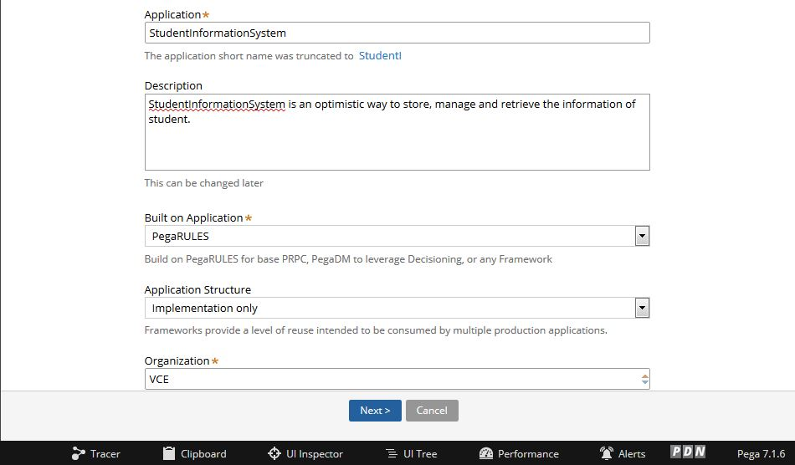

In Application Settings, Details such as Application Name, Description, Built on Application, Application Structure and Organisation are given.

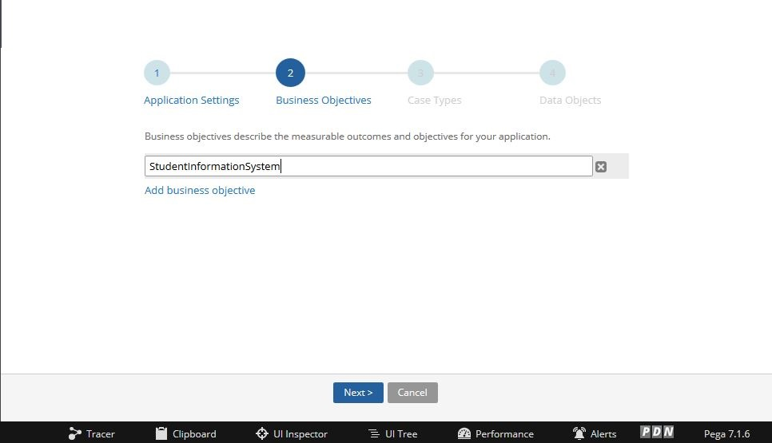

In Business Objective wizard, we enter the Business Objective of the Application.

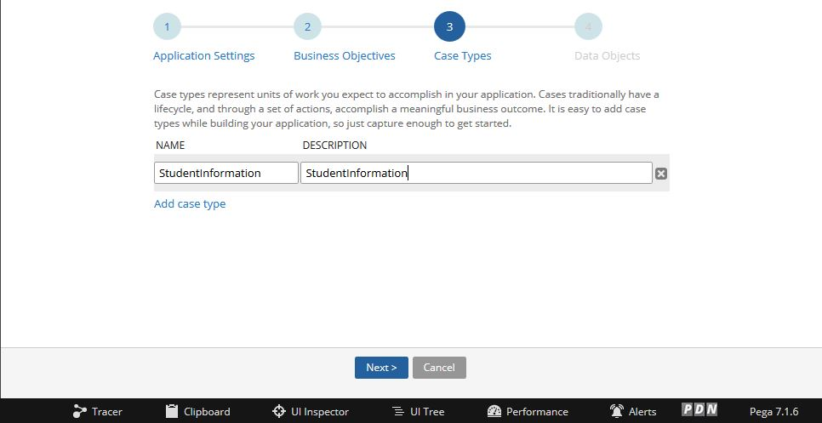

Case Types represents the units of work we expect to accomplish in our Application. Case Types Wizard includes Name and Description of the Case Types.

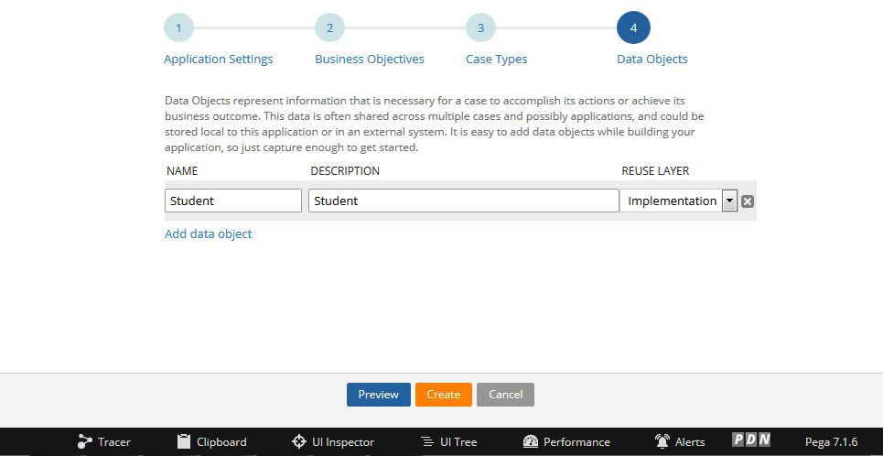

Data Object Name and Description are entered in the Data Objects Wizard.

2. Configure Stages and Steps:
Configure the stages and steps in the case designer of the case, in the Stages and Processes Tab. We have a stage configured as happy path.

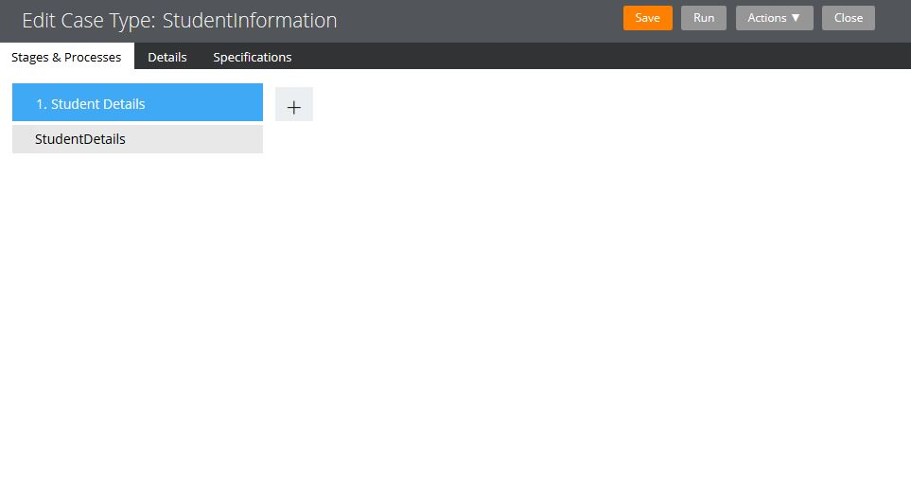
Student Information System includes a stage named Student Details with a step in it.

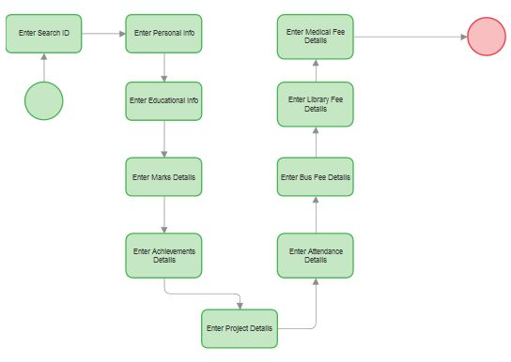

Student Details step is a Screen Flow which contains 10 different Assignments.

- Enter SearchID:
In ‘Enter SearchID’, we enter IDNumber which acts as a key and retrieves the details of the student that whose IDNumber matches with the entered IDNumber. If the operator wants to enter the details of the student, he can simply click Next, by leaving the IDNumber field blank.
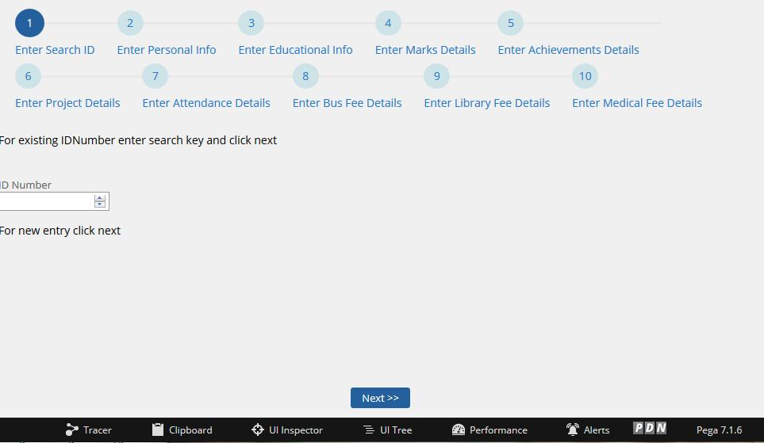
- Enter PersonalInfo:

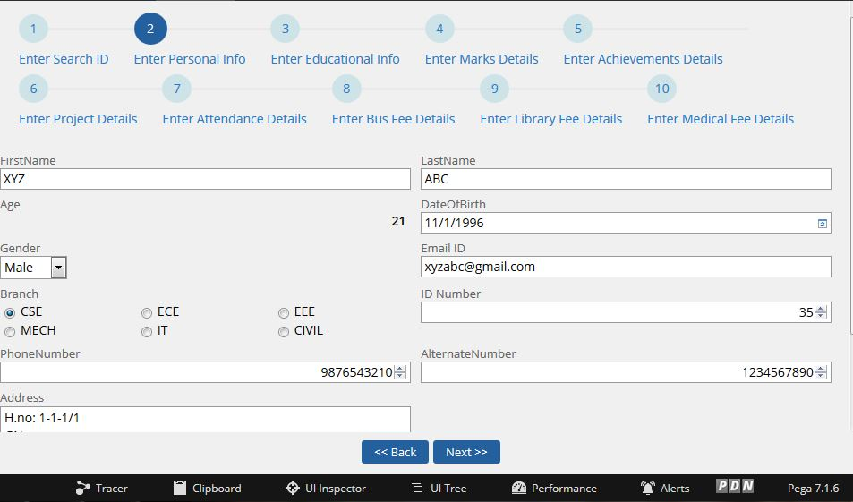

In ‘Enter PersonalInfo’, we enter Personal Details such as First Name, Last Name, Date of Birth, Email ID and many. When we enter the Date of Birth, the Age is calculate automatically
- Enter EducationalInfo
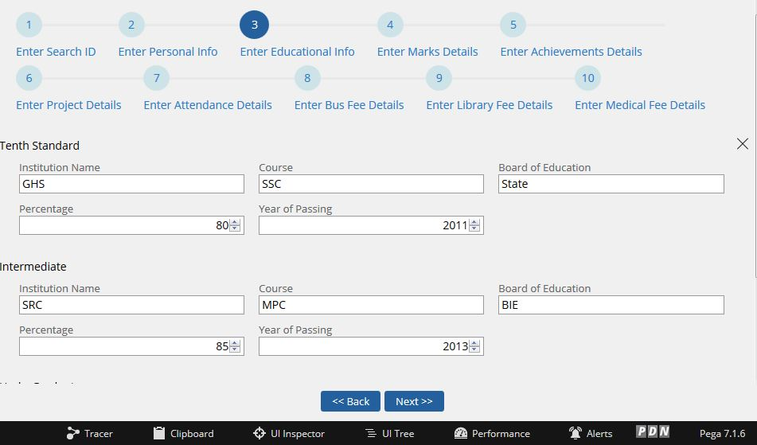
- Enter Marks Details
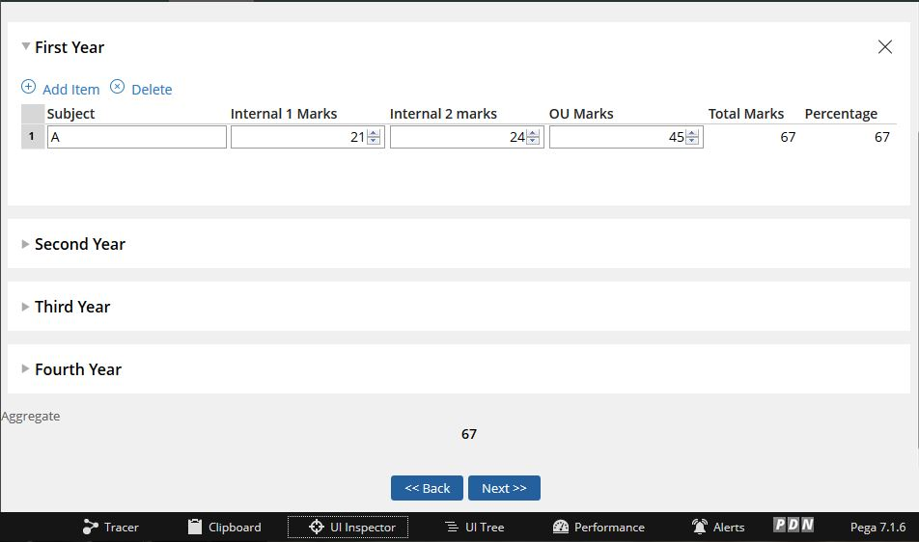

- Enter Achievements Details
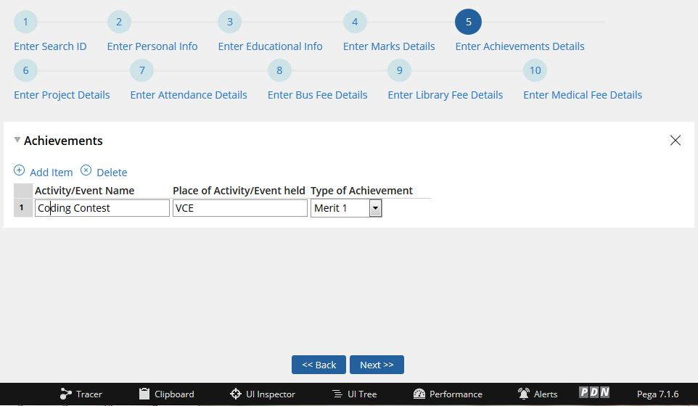
- Enter Project Details
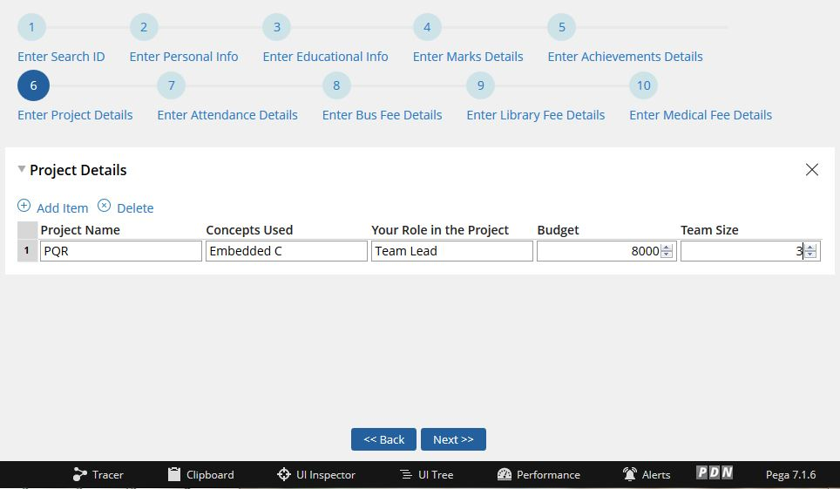

- Enter Attendance Details:
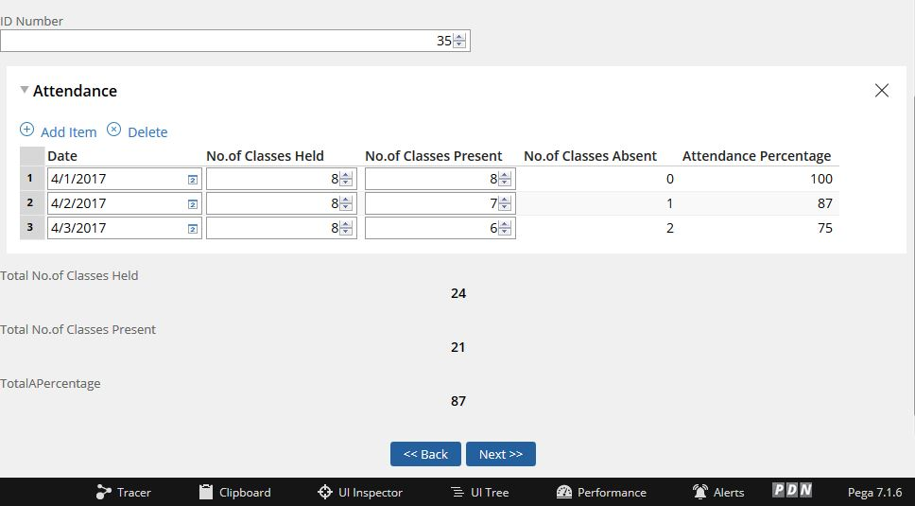

- Enter Bus Fee Details:
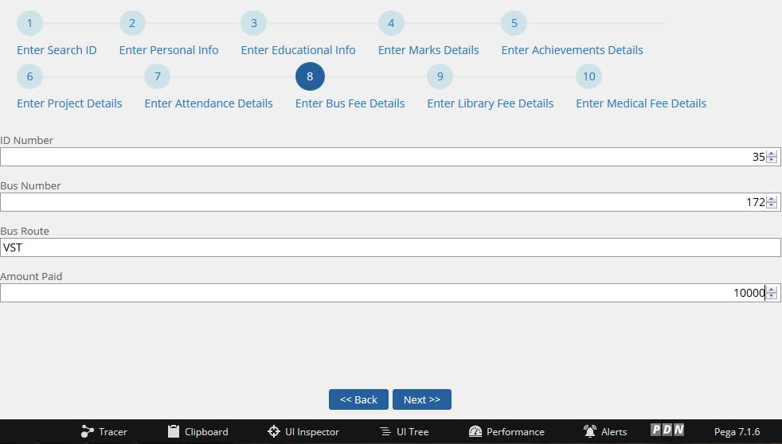

- Enter Library Fee Details:
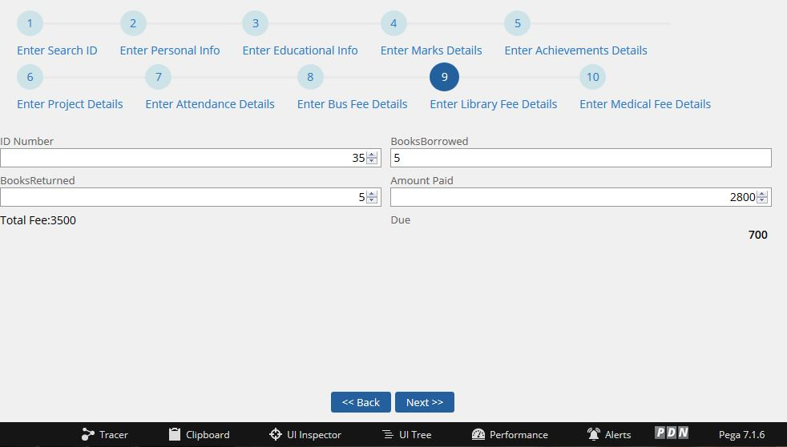

- Enter Medical Fee Details
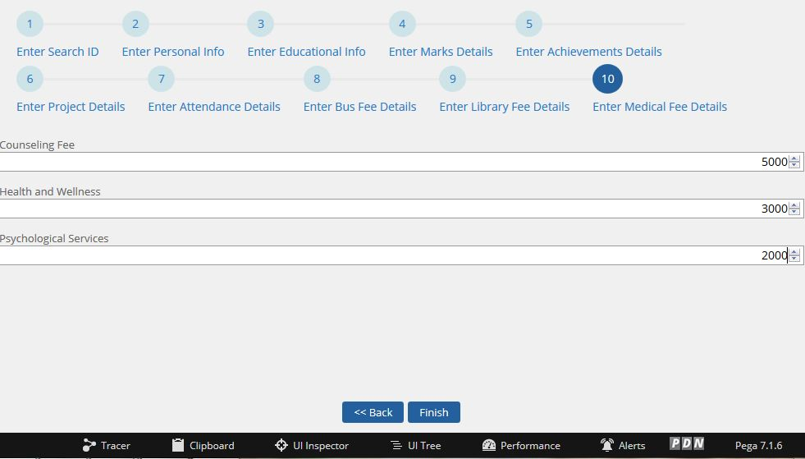

3. Configuring the Activity Rule:
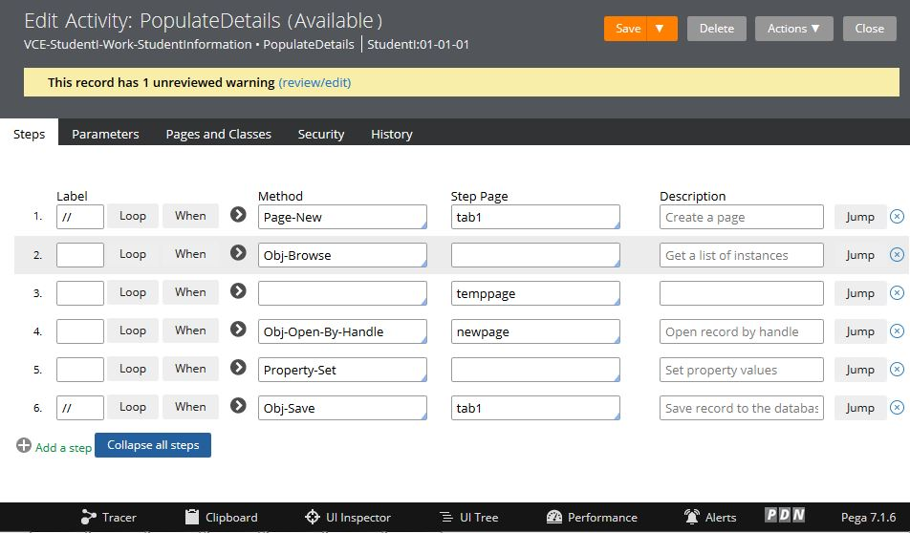

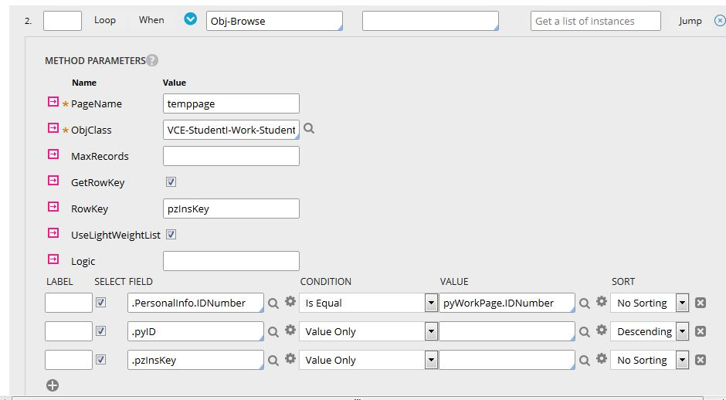
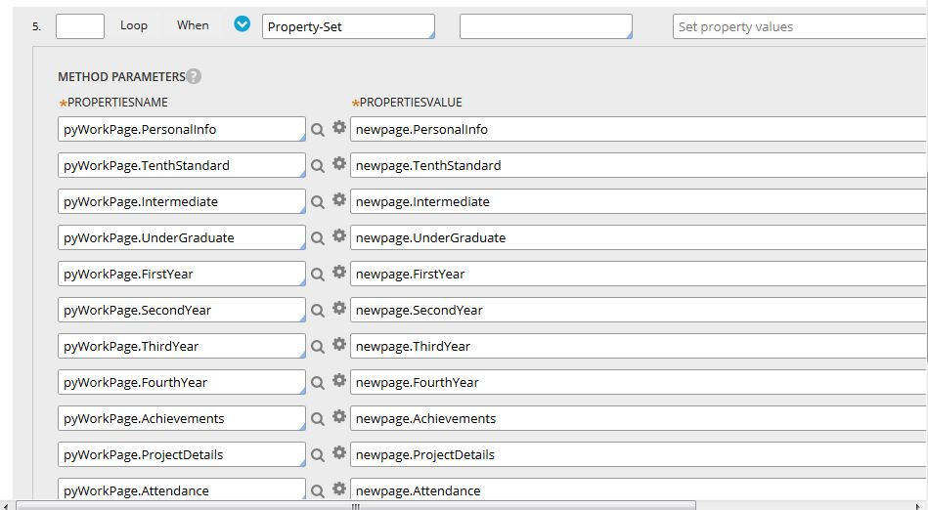

Rulesets:

RuleSet | Version | Description | Prerequisites
StudentI | 01-01-01 | RuleSet to identify, manage, and control the set of rule instances that define StudentI application | StudentIInt:01-01-01  VCE:01-01-01
StudentIInt | 01-01-01 | Integration RuleSet for StudentIInt application | Pega-ProcessCommander:07-10-99
VCE | 01-01-01 | RuleSet to identify, manage, and control the set of rule instances that define VCE application | VCEInt:01-01-01  UI-Kit-7:01-01-01
VCEInt | 01-01-01 | Integration ruleset for organization | Pega-ProcessCommander:07-10-99
UI-Kit-7 | 01-01-01 |  | Pega-ProcessCommander:07-10-99

References
- https://community.pega.com/

